STAT 230 CAA #1

*Aania Raheem*

*a4raheem*

*20870815*

Question 1

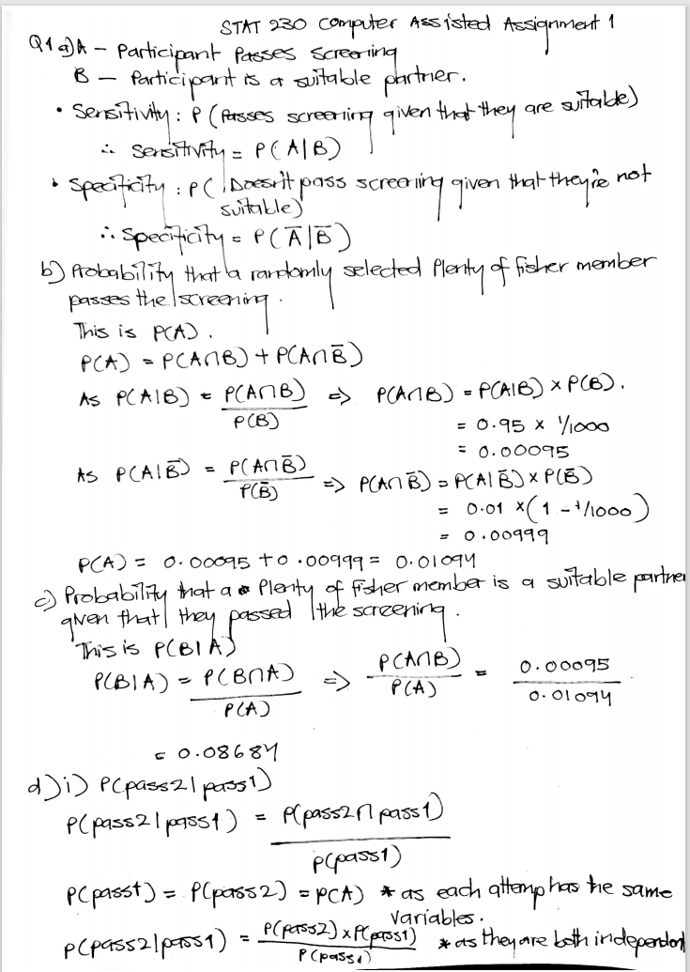

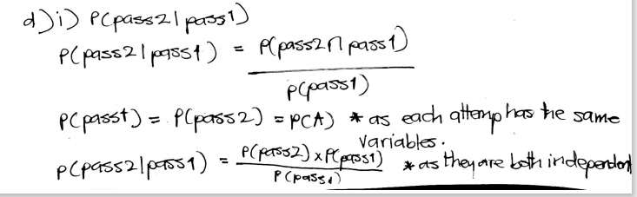

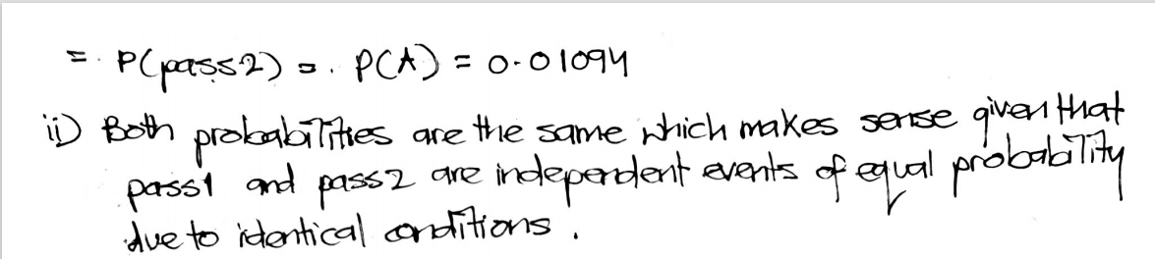

iii)

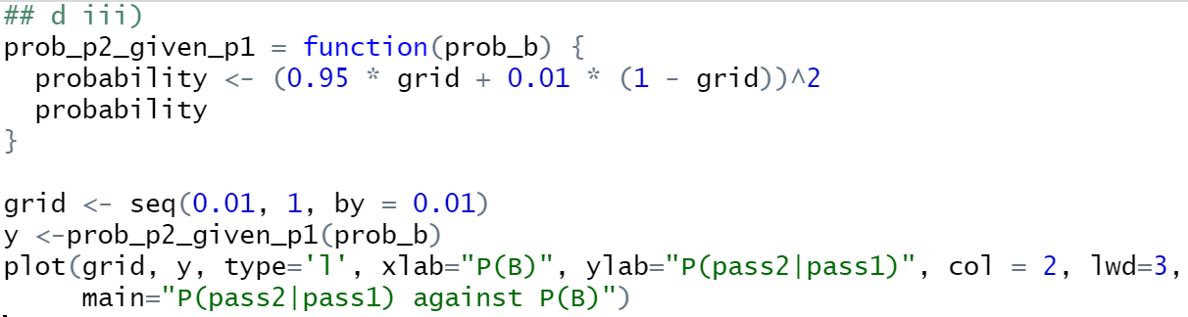

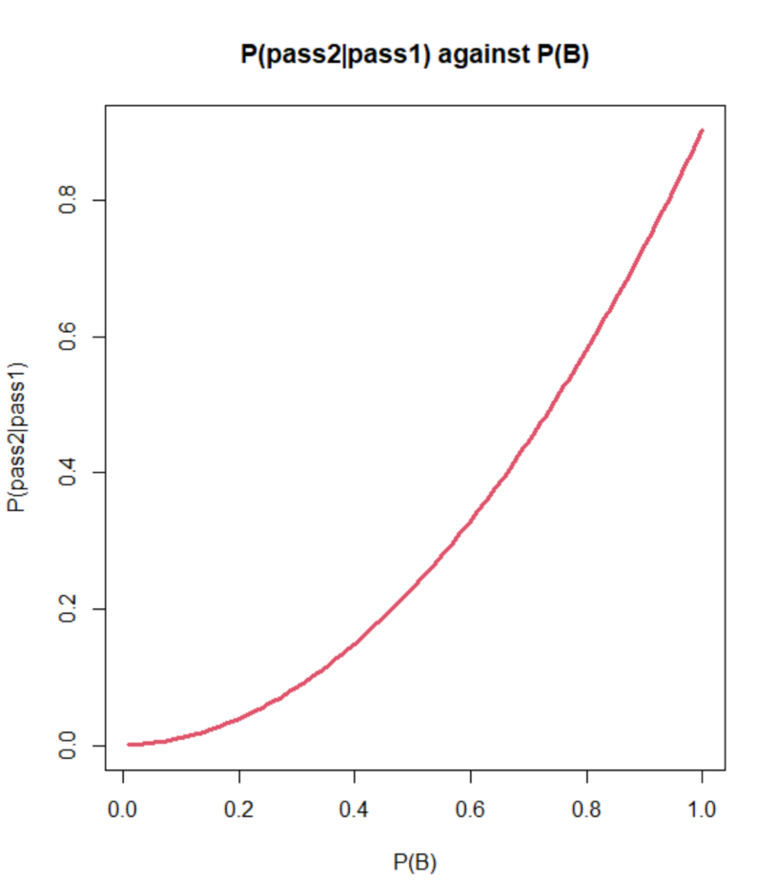

P(pass2|pass1) seems to increase at an increasing rate as P(B)’s value increases.

Question 2

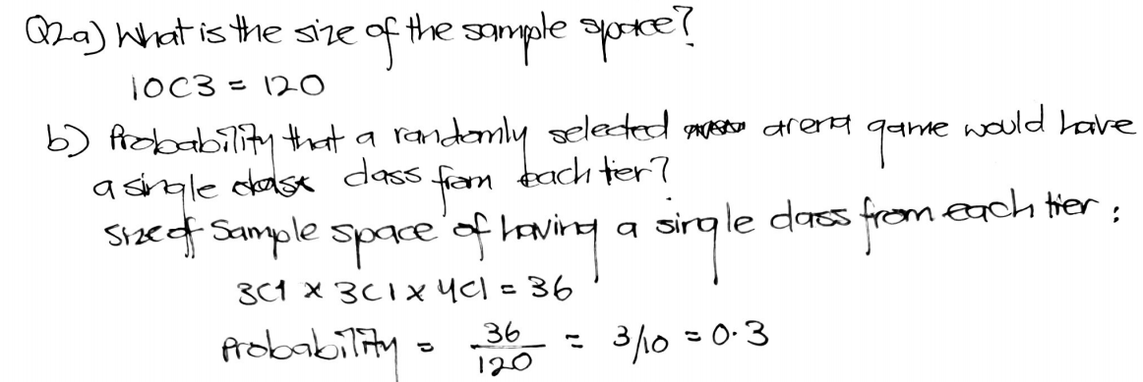

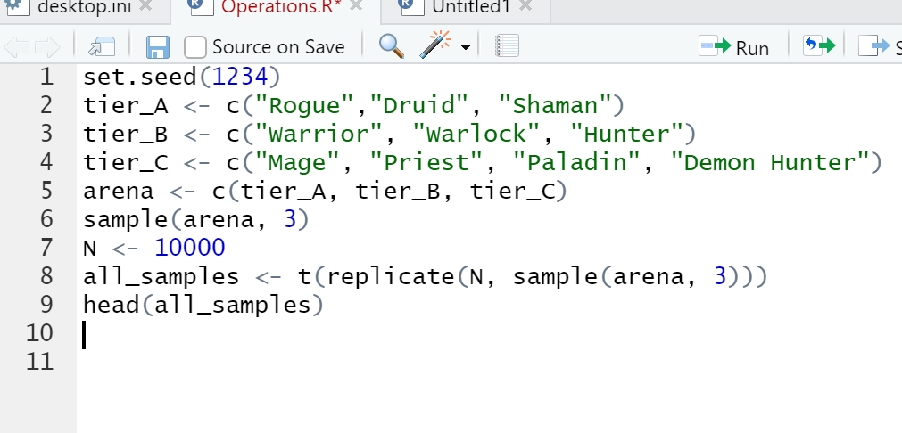ci)



cii)

Code:

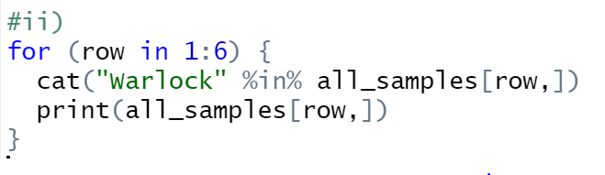

Output:

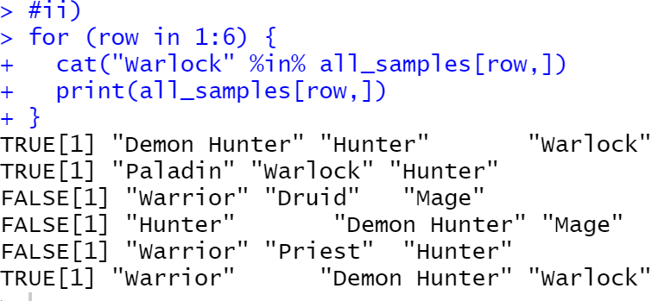

ciii)

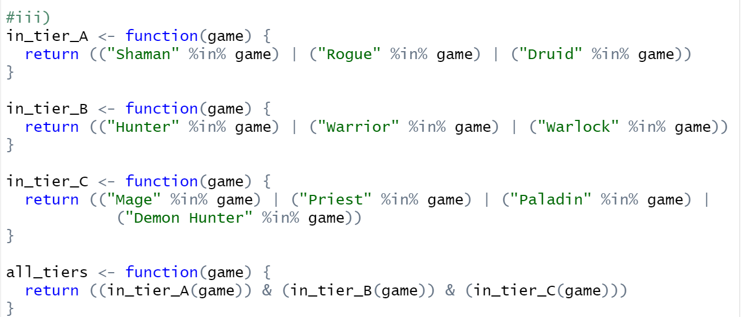

civ)

Code:

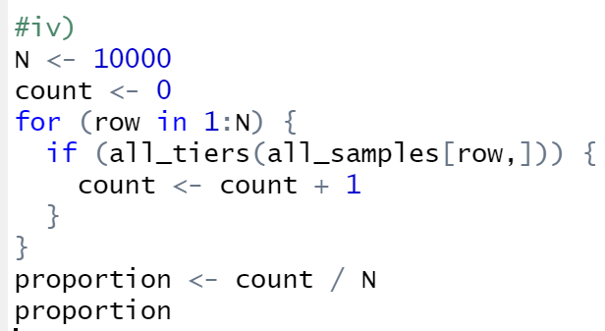

Output:

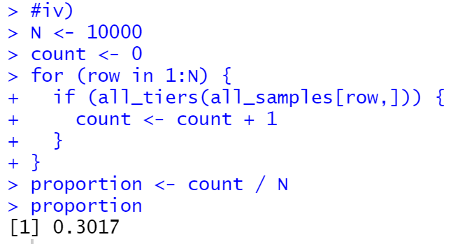

The probability calculated is approximately equal to the one calculated in b) so this result does agree with my own calculation.

di)

Code:

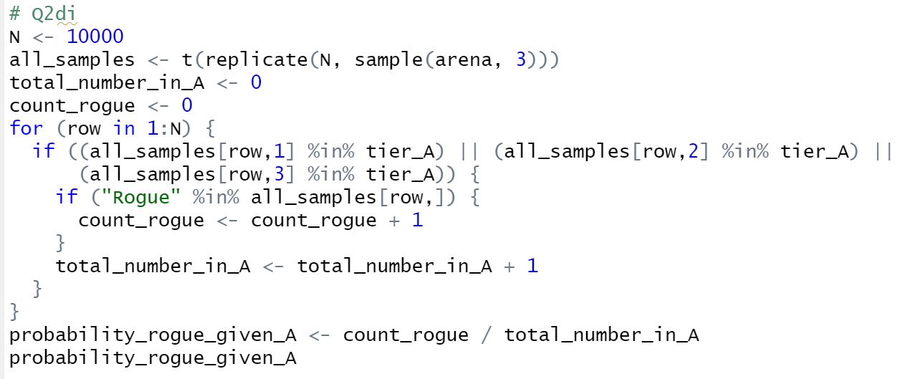

Output:



dii)

Code:

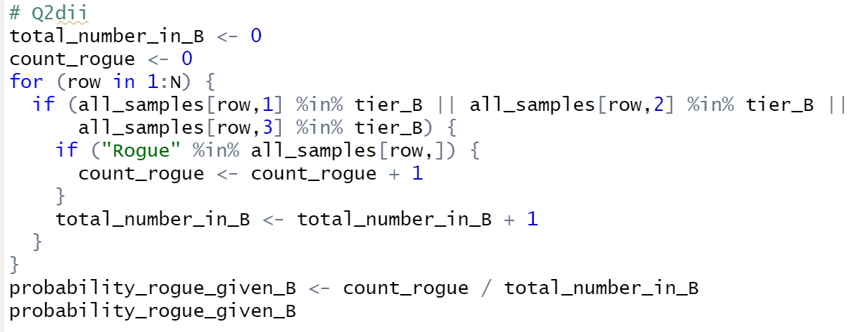

Output:



diii)

The probability in di) is higher than that it dii) since P(Rogue) intersection with P(At least one from Tier A) is much higher as Rogue showing up satisfies the condition of at least one from Tier A showing up, thus the event of Rogue showing up interlaps completely with part of the event of at least 1 from Tier A showing up. Thus, by the formula of conditional probability its numerator will be much higher, making the probability higher than that in dii)

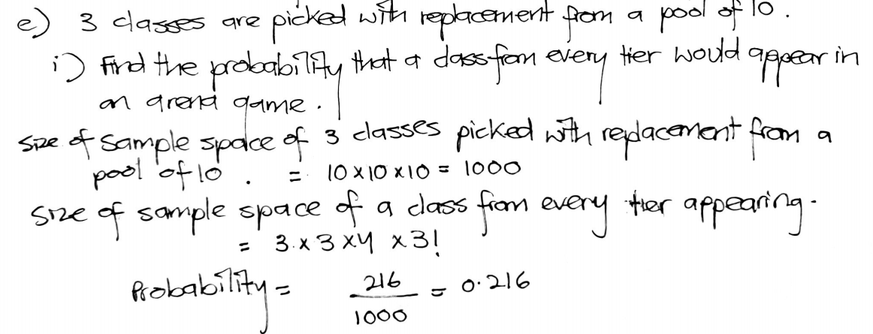

eii)

Code:

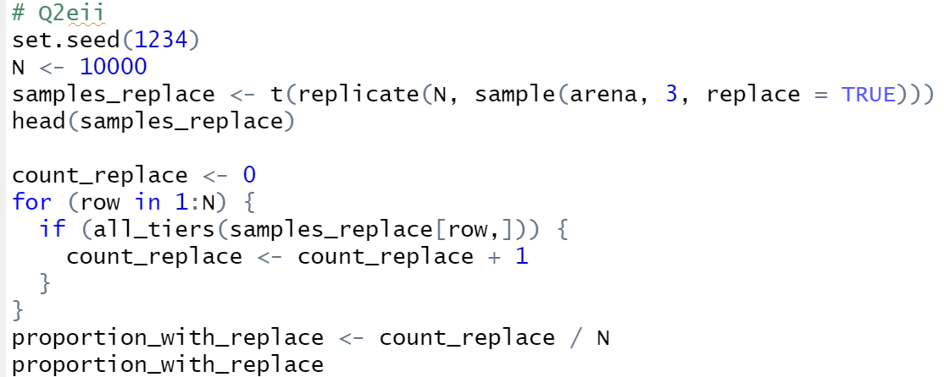

Output:



Since my answer in ei) is approximately equal to the answer computed in eii), it is correct.

Question 3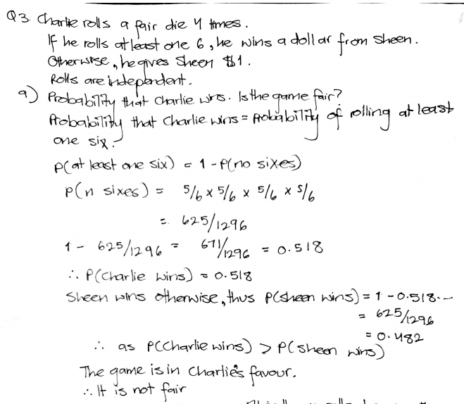

b)

Code:

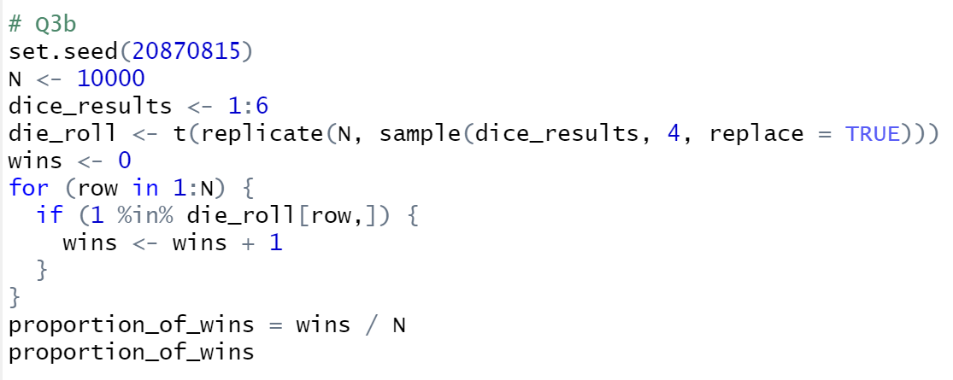

Output:



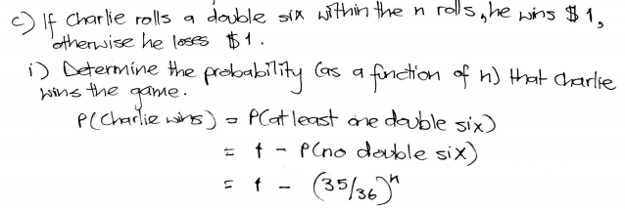

cii)

Code

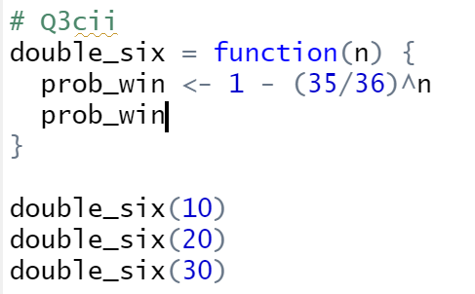

Output:

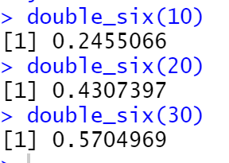

ciii)

Code:

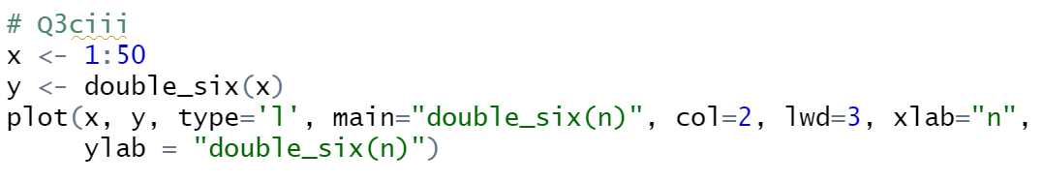

Output:

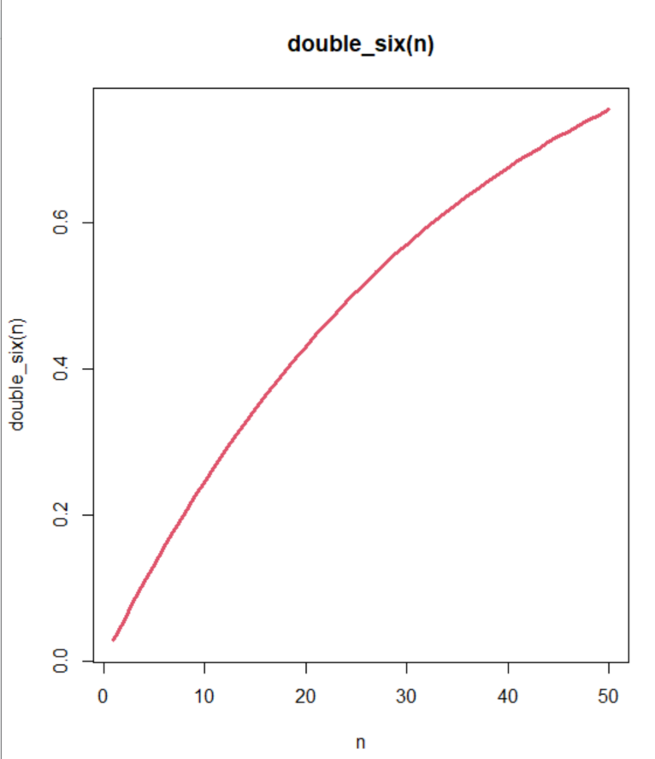

This function is monotonic in this particular range as it is continuously increasing (albeit at a decreasing rate).

civ)

Code:

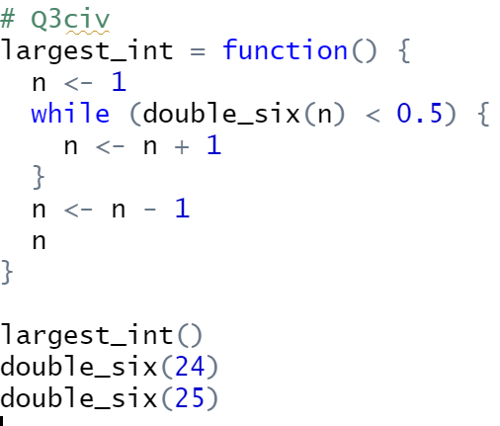

Output:

